* ECG signal analysis for the assessment of sleep-disordered breathing and sleep pattern

2011

The ECG is modulated by respiration, sleep, and the autonomic nervous system, often in a specific manner. Therefore, the reconstruction of a physiological trait from the ECG by means of signal analysis is often possible. Compared to a complete polysomnography, the measurement of the ECG is less stressful for the patient and there is less sleep disturbance by the technical equipment. With a signal strength of 1–2 mV, the ECG achieves the best signal-to-noise ratio among all electro-physiological signals. Therefore, the ECG generally provides reliable results, even in unattended measurements in the patients’ domestic environment.

Method

1. determine heart rate from ECG signal – detect location of R wave

2. detection of cyclic heart rate variations -Repetitive episodes of apnea during sleep induce periodic oscillations of the heart rate described as CVHR. CVHR can be used for the localization of apnea segments and for the diagnostic identification of sleep apnea.

The correlation between test pattern and heart rate is calculated for each time position resulting in a continuous curve over the recording period.

3. Estimation of sleep stages from the heart rate signal

Limitation

it is based on HRV (heart rate variability) alone. HRV may be influenced by other sleep pathology or heart problems

<https://link-springer-com.ezproxy1.library.usyd.edu.au/article/10.1007/s11517-011-0853-9>

* A Novel Algorithm for the Automatic Detection of Sleep Apnea From Single-Lead ECG

2015

1. 1-min-segments & filter the noise

2. ECG contamination level – estimate reliability of result

where a weight ω is assigned to each ECG segment depending on how similar its autocorrelation function (ACF) is to the ACFs of the past segments.

3. EDR

4. feature based on QRS

<https://ieeexplore-ieee-org.ezproxy1.library.usyd.edu.au/document/7084597>

* Robust artefact detection in long-term ECG recordings based on autocorrelation function similarity and percentile analysis

2012

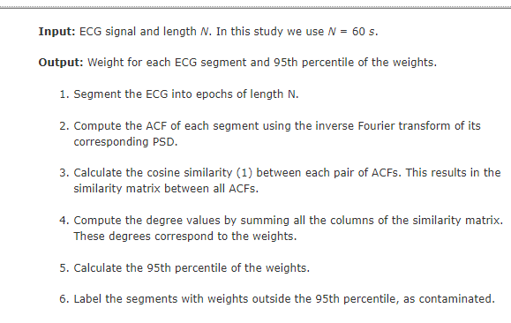

<https://ieeexplore-ieee-org.ezproxy1.library.usyd.edu.au/document/6346633>

